Important Things About Event Hire

In the realm of social gatherings and jubilant celebrations, the allure of diverse services has taken center stage. Among these, the enchantment of photo booth rental reigns supreme in the ever changing landscape of event hire and party hire. These services bring an extra layer of charm and vibrancy to various occasions. Event hire and party hire have gained remarkable popularity, offering a wide array of conveniences. Chair hire, table hire, and furniture hire are pivotal components of these services, adorning the canvas of events with practicality and elegance. These elements seamlessly blend functionality with style, catering to diverse themes and preferences. Amid the tapestry of services, photo booth hire emerges as a star attraction. These delightful contraptions capture moments in time, preserving the joyous spirit of gatherings. With a whimsical touch, they provide a space for laughter and spontaneity, etching memories that linger long after the event concludes. If you are seeking to learn more about event hire sussex, browse the above site.

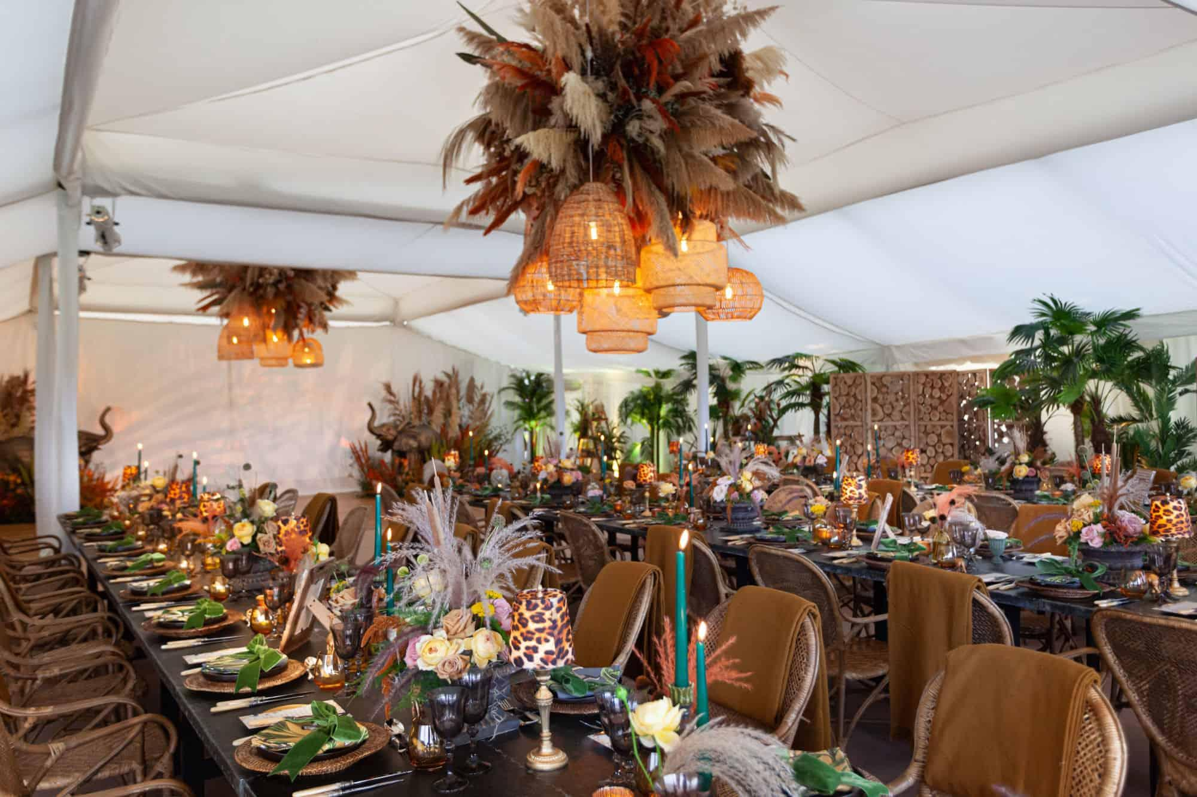

Adding an element of enchantment, bell tents for hire introduce a unique twist to outdoor events. These whimsical retreats offer a cozy haven for guests, replete with an aura of intimacy amidst nature's embrace. Bell tents have become synonymous with relaxation and rustic charm, transforming event spaces into picturesque escapes. The beauty of these services lies in their ability to transcend the ordinary, elevating gatherings into unforgettable experiences. Be it a lavish wedding or a spirited corporate affair, the versatility of these offerings knows no bounds. The underlying essence is to weave comfort and creativity seamlessly into the fabric of each event. Event hire and party hire services intertwine harmoniously, orchestrating seamless functions without the fuss of ownership. The pragmatic concept of chair hire, table hire, and furniture hire speaks to the heart of practicality, ensuring every guest finds their place with ease.

The symphony of convenience and aesthetics is the hallmark of these services. At the heart of the event landscape, photo booth hire stands as a testament to the era's spirit. It captures the essence of spontaneity and camaraderie, providing a playground for guests to express themselves. The frames become canvases of jubilation, forming a tangible mosaic of shared laughter and joy. Meanwhile, the allure of bell tents for hire offers a fresh perspective on outdoor revelries. Nestled under the open sky, these tents evoke a sense of adventure and intimacy. The soft glow of string lights and the fragrance of nature combine to create an enchanting atmosphere, where memories are etched in starlight. In the ever evolving realm of event hire and party hire, these services emerge as beacons of innovation. Chair hire, table hire, and furniture hire anchor the logistics, while photo booth hire and bell tents for hire infuse a sprinkle of magic. Together, they redefine celebrations, leaving an indelible mark on the canvas of time.

